Inspiration Games Research

DIG2783

Dexavier Williams

9/8/2019

1. Super Mario Bros 1

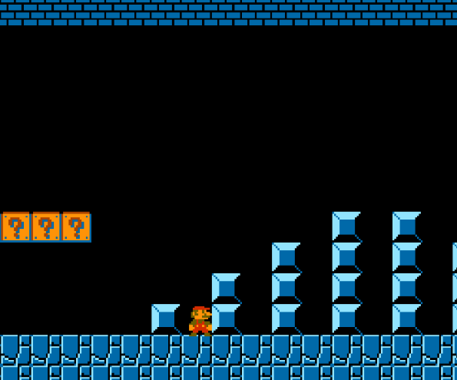 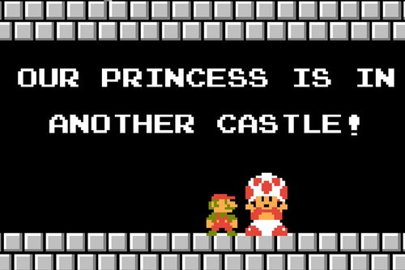

The game I want to create will have a similar playstyle and storyline like the original Mario Bros game. I want to develop a game with the basic mechanics of Mario like running and jumping. My game also has a similar story to Mario, the main difference being that there are multiple damsels in distress instead of one. Each new level and the boss fights will also have a new orphan that needs rescuing, unlike Mario where only the boss fights supposedly have the Princess.

2. Sonic the Hedgehog

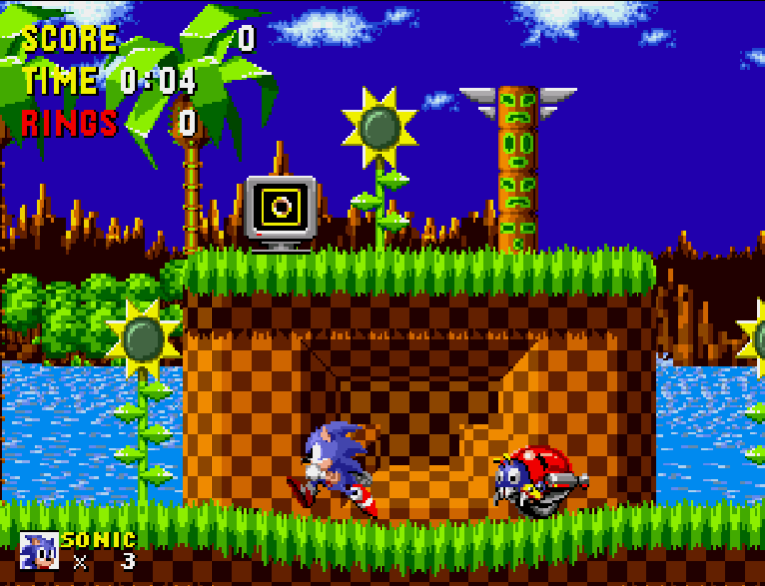 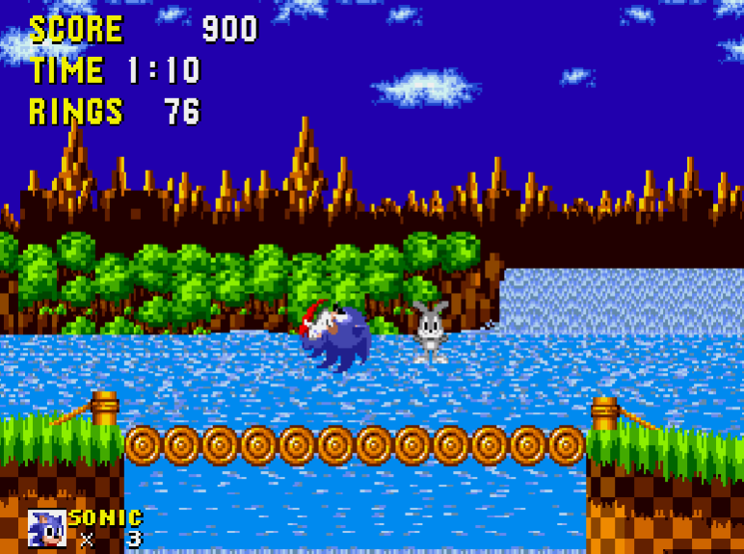

Sonic goes around rescuing animals that are trapped in robotic shells throughout each level. While the narrative is like mine, I’m more focused on trying to emulate its artistic style. My game’s main character is a genius superhero who battles drug dealers to rescue his fellow orphans. I want to make it visually similar to Sonic.

3. Donkey Kong Country 1

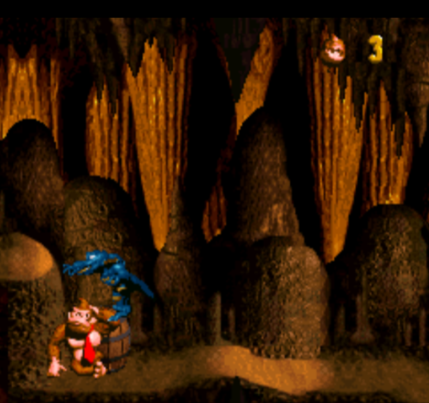 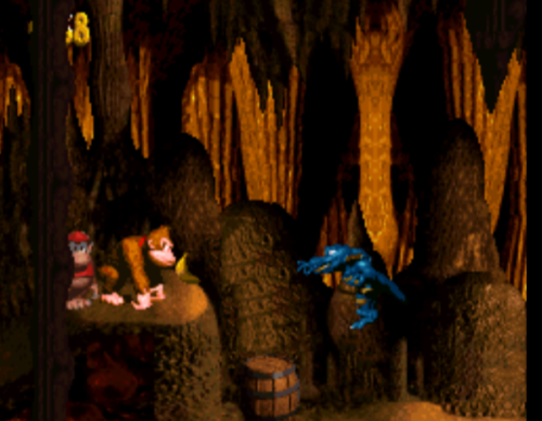

Donkey Kong Country is another 2d platformer with the rescuing narrative. The only difference is he wants to collect his stolen food, not any kidnapped animal or human. The main point of my game is you’re an unlikely hero who steps up to retrieve something that was lost. That is the main way I get influence from the Donkey Kong Country series.

Note: I played each one of these games on online emulators and screenshotted it with my PrtScr button. While these three games play a huge influence on my game’s storyline and overall creation, I gather ideas from various types of media. Everything from classic hero comics to Crash Bandicoot and even internet stories can influence new ideas within me.